  

**Srinivasamohan Ponnusamy**

**Movate Technologies Pvt Ltd**

**Delivery Director**



**Hearty Thank You for Being**

**A Jury of Hackfest’24**

**Organized By**  
 Department of Computer Science and Engineering

  

**A. Vivek Bharath Kumar**

**Movate Technologies Pvt Ltd**

**Director**



**Hearty Thank You for Being**

**A Jury of Hackfest’24**

**Organized By**  
Department of Computer Science and Engineering

 

**Gayatri Mohanakrishnan**

**Movate Technologies Pvt Ltd**

**Vice President, Enterprise product support**



**Hearty Thank You for Being**

**A Jury of Hackfest’24**

**Organized By**  
Department of Computer Science and Engineering

  

**Guru Saravana Balaji P**

**Ignitho Technologies**

**Associate Lead - AI Engineer**

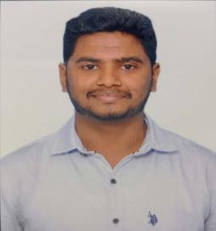

**Hearty Thank You for Being**

**A Jury of Hackfest’24**

**Organized By**  
 Department of Computer Science and Engineering

 

**Thirumurugan R**

**Ignitho Technologies**

**Lead Data Scientist (Artificial Intelligence/ Machine Learning)**



**Hearty Thank You for Being**

**A Jury of Hackfest’24**

**Organized By**  
Department of Computer Science and Engineering

  

**Biju Vargheese**

**Ignitho Technologies**

**VP Delivery**

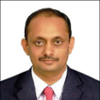

**Hearty Thank You for Being**

**A Jury of Hackfest’24**

**Organized By**  
Department of Computer Science and Engineering

 

**Joel Prashanth J**

**BOTVFX India Private Limited**

**Product Manager- Software Development**



**Hearty Thank You for Being**

**A Jury of Hackfest’24**

**Organized By**  
Department of Computer Science and Engineering

 

**Karthick Ramadoss**

**BOTVFX India Private Limited**

**Manager - Human Resources**



**Hearty Thank You for Being**

**A Jury of Hackfest’24**

**Organized By**  
Department of Computer Science and Engineering

 

**Dr. S. Poonkuzhali**

**Professor, Rajalakshmi Engineering College**

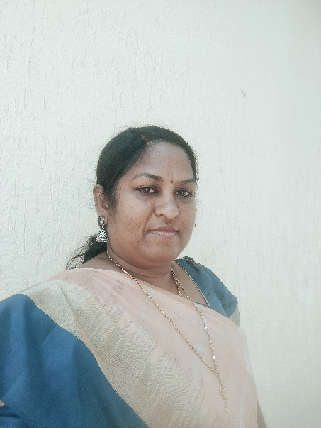

**Hearty Thank You for Being**

**A Jury of Hackfest’24**

**Organized By**  
Department of Computer Science and Engineering

 

**Dr. S. Vinod Kumar**

**Professor, Rajalakshmi Engineering College**

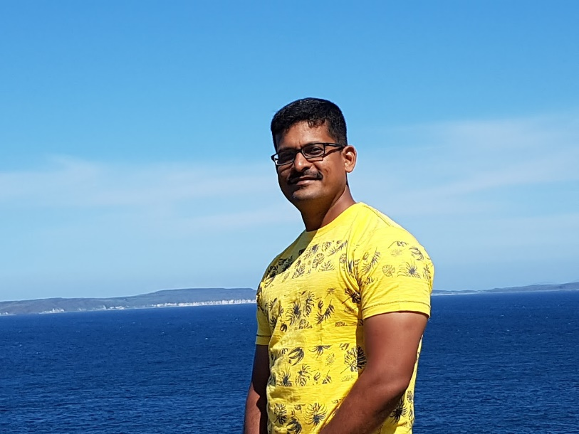

**Hearty Thank You for Being**

**A Jury of Hackfest’24**

**Organized By**  
Department of Computer Science and Engineering

 

**Dr. N.Srinivasan**

**Professor, Rajalakshmi Engineering College**

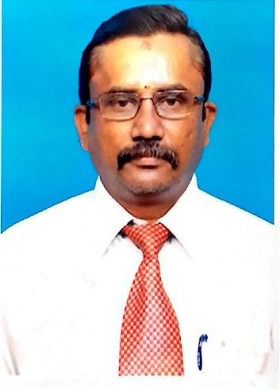

**Hearty Thank You for Being**

**A Jury of Hackfest’24**

**Organized By**  
Department of Computer Science and Engineering

 

**Dr.K.Anantha Jothi**

**Professor, Rajalakshmi Engineering College**

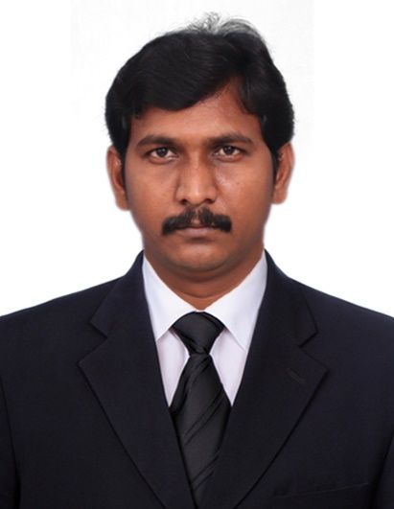

**Hearty Thank You for Being**

**A Jury of Hackfest’24**

**Organized By**  
Department of Computer Science and Engineering

 

**Dr.K.Anand**

**Professor, Rajalakshmi Engineering College**

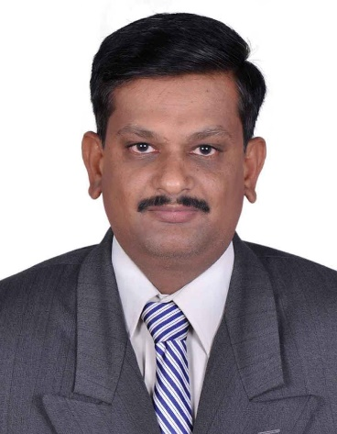

**Hearty Thank You for Being**

**A Jury of Hackfest’24**

**Organized By**  
Department of Computer Science and Engineering

 

**Dr.N.Duraimurugan**

**Associate Professor, Rajalakshmi Engineering College**

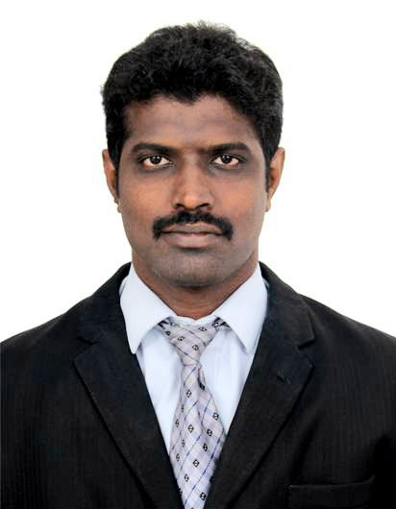

**Hearty Thank You for Being**

**A Jury of Hackfest’24**

**Organized By**  
Department of Computer Science and Engineering

 

**Dr.S.Senthil Pandi**

**Associate Professor, Rajalakshmi Engineering College**

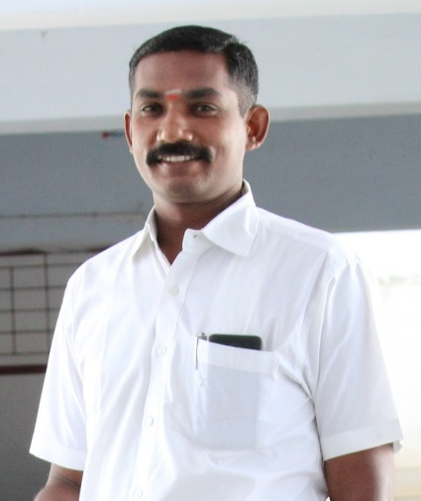

**Hearty Thank You for Being**

**A Jury of Hackfest’24**

**Organized By**  
Department of Computer Science and Engineering

 

**Dr.T.Kumaragurubaran**

**Assistant Professor S. G, Rajalakshmi Engineering College**

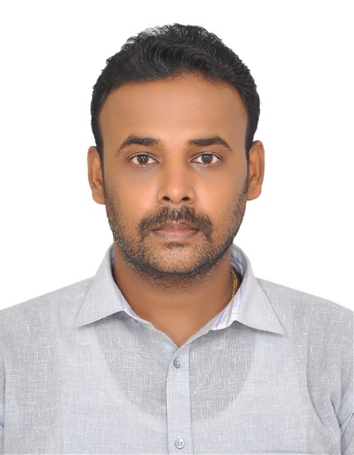

**Hearty Thank You for Being**

**A Jury of Hackfest’24**

**Organized By**  
Department of Computer Science and Engineering